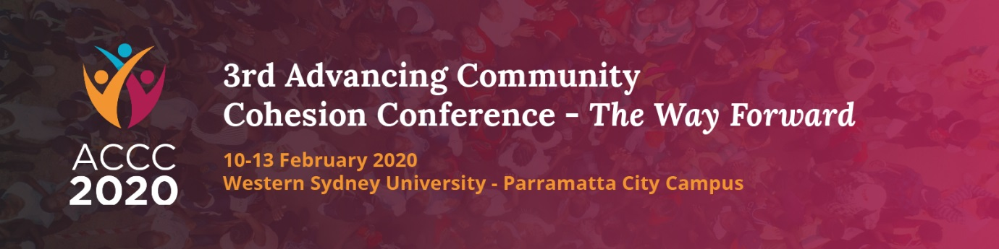
Take Advantage of Early Bird Registration
The draft program of the 3rd Advancing Community Cohesion Conference – The Way Forward (ACCC) has been released. It contains the names of Australian and international experts and reads like Who is Who in Multicultural Australia. It includes experts from academia, government and voluntary sector delivering keynotes and practical workshops.
Take advantage of the low Early Bird for Registration fees as they end in mid-January 2020. View the draft program and register online at: http://www.advancingcommunitycohesionconference.com.au/
The 3rd ACCC will be held on the 10-13th of February 2020 at Western Sydney University Parramatta City Campus.
This Conference is designed to achieve practical outcomes and inform participants’ ongoing work in the social cohesion space, to contribute to policies and strategies at national, state and local levels as well as provide opportunities to build new networks that facilitate partnerships and collaboration. Presenting some of the most renowned Australian and international speakers, the event offers great value to a wide range of audiences seeking to understand contemporary issues in the advancement of social harmony and inclusion.
See you in Parramatta on 10-13th February 2020.
Sev
Prof. Sev Ozdowski AM
Conference Convenor, Western Sydney University
Chair, Australian Multicultural Council

